State of Texas Emergency Management Plan

Solar Eclipse Event Plan

February 2024

Purpose
The purpose of the Solar Eclipse Event Plan is to describe the situation, provide the concept of operations, and identify the expected responsibilities required of stakeholders specific to the total solar eclipse event.

Scope
The Solar Eclipse Event Plan is categorized as a special event plan to supplement the State of Texas Emergency Management Basic Plan. A special event plan is a one-time use plan for a forthcoming event or natural phenomenon that raises concern for the state. A special event plan describes unique circumstances and coordination structures with specific information not stated in the Basic Plan.

Situation Overview
On Monday, April 8, 2024, from approximately 1:27 PM to 1:49 PM, the state of Texas will experience a total solar eclipse that will cover a roughly 124-mile-wide path, ascending in a northeasterly direction from Eagle Pass to Texarkana. At approximately 1:49 PM, the eclipse will cross over into Oklahoma and Arkansas. Totality will last from a few seconds to about four and a half minutes depending on the location along the path. Only those in the path of totality will get the full eclipse experience. A partial solar eclipse will be seen before and after the time of greatest coverage beginning around noon and lasting for about two and a half hours. A total of 83 Texas counties are within the path of totality. The Texas Division of Emergency Management expects that this event has the potential to produce emergency situations that may require state support.

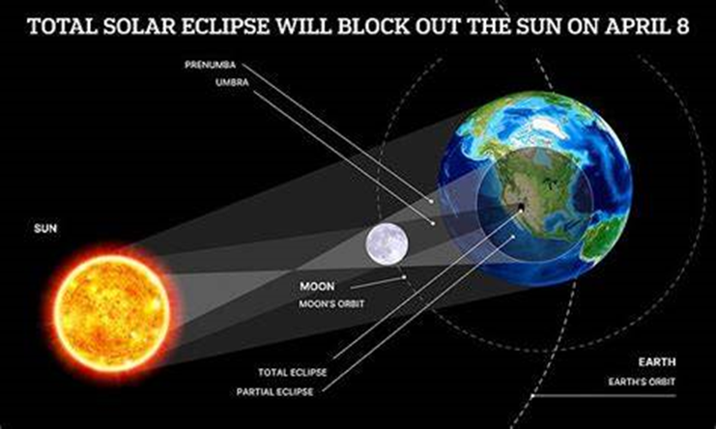

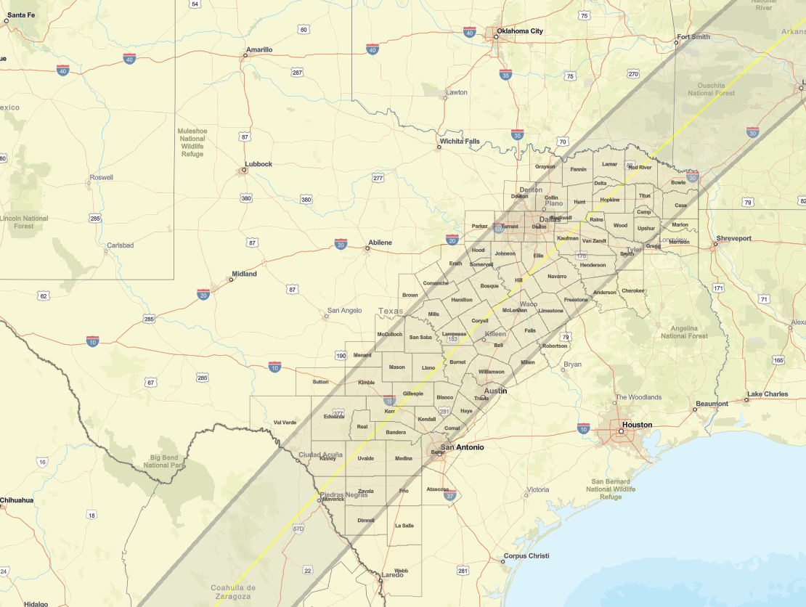
Below is a map of the 83 Texas counties in the path of totality with a population estimated to be about 15,868,234:

Below is a breakdown of the estimated duration of totality per county, based on
the Texas Division of Emergency Management disaster regions:

TDEM Region 6:

County | Start Time | End Time | FY24 Total Pop | Sq Mi in Path | Total Sq Mi | Area in Path
Maverick | 1:27 PM | 1:32 PM | 59,160 | 1,291.51 | 1,291.51 | 100.00%
Kinney | 1:28 PM | 1:33 PM | 2,981 | 1,364.09 | 1,364.09 | 100.00%
Dimmit | 1:29 PM | 1:31 PM | 8,329 | 890.96 | 1,318.33 | 67.58%
Zavala | 1:29 PM | 1:33 PM | 9,333 | 1,298.59 | 1,298.59 | 100.00%
Uvalde | 1:29 PM | 1:34 PM | 24,072 | 1,563.35 | 1,563.35 | 100.00%
Atascosa | 1:30 PM | 1:33 PM | 50,234 | 5.22 | 1,217.96 | 0.43%
Real | 1:30 PM | 1:35 PM | 2,751 | 699.91 | 699.91 | 100.00%
Edwards | 1:30 PM | 1:42 PM | 1,379 | 1,936.45 | 2,120.62 | 91.31%
La Salle | 1:31 PM | 1:33 PM | 6,564 | 0.06 | 1,505.72 | 0.00%
Medina | 1:31 PM | 1:34 PM | 52,651 | 1,312.66 | 1,337.15 | 98.17%
Val Verde | 1:31 PM | 1:34 PM | 47,067 | 834.20 | 3,232.49 | 25.81%
Bandera | 1:31 PM | 1:35 PM | 21,902 | 797.67 | 797.67 | 100.00%
Kerr | 1:31 PM | 1:36 PM | 53,712 | 1,107.26 | 1,107.26 | 100.00%
Frio | 1:32 PM | 1:33 PM | 18,565 | 469.68 | 1,131.99 | 41.49%
Bexar | 1:32 PM | 1:34 PM | 2,099,496 | 621.37 | 1,257.37 | 49.42%
Kendall | 1:32 PM | 1:36 PM | 48,325 | 662.97 | 662.97 | 100.00%
Gillespie | 1:32 PM | 1:37 PM | 27,419 | 1,061.44 | 1,061.44 | 100.00%
Comal | 1:34 PM | 1:36 PM | 186,525 | 431.24 | 575.11 | 74.98%

TDEM Region 5:

County | Start Time | End Time | FY24 Total Pop | Sq Mi in Path | Total Sq Mi | Area in Path
Webb | 1:30 PM | 1:33 PM | 272,899 | 87.52 | 3,374.11 | 2.59%

TDEM Region 7:

County | Start Time | End Time | FY24 Total Pop | Sq Mi in Path | Total Sq Mi | Area in Path
Sutton | 1:31 PM | 1:32 PM | 3,206 | 139.45 | 1,448.84 | 9.62%
Kimble | 1:32 PM | 1:35 PM | 4,376 | 1,184.21 | 1,249.98 | 94.74%
Menard | 1:33 PM | 1:34 PM | 1,931 | 308.07 | 902.27 | 34.14%
Mason | 1:33 PM | 1:37 PM | 3,881 | 933.65 | 933.65 | 100.00%
McCulloch | 1:35 PM | 1:36 PM | 7,428 | 612.35 | 1,074.09 | 57.01%

TDEM Region 8:

County | Start Time | End Time | FY24 Total Pop | Sq Mi in Path | Total Sq Mi | Area in Path
Blanco | 1:33 PM | 1:37 PM | 12,137 | 713.80 | 713.80 | 100.00%
Llano | 1:34 PM | 1:38 PM | 22,122 | 966.46 | 966.46 | 100.00%
Hays | 1:35 PM | 1:37 PM | 278,142 | 505.85 | 678.62 | 74.54%
Travis | 1:35 PM | 1:38 PM | 1,371,367 | 796.12 | 1,024.85 | 77.68%
San Saba | 1:35 PM | 1:39 PM | 5,700 | 1,137.95 | 1,137.95 | 100.00%
Lampasas | 1:35 PM | 1:39 PM | 22,473 | 714.03 | 714.03 | 100.00%
Williamson | 1:36 PM | 1:39 PM | 694,277 | 1,028.98 | 1,136.22 | 90.56%
Bell | 1:36 PM | 1:40 PM | 391,047 | 1,086.75 | 1,086.75 | 100.00%
Hamilton | 1:36 PM | 1:40 PM | 8,190 | 836.19 | 836.19 | 100.00%
Milam | 1:36 PM | 1:40 PM | 25,089 | 447.19 | 1,021.55 | 43.78%
Coryell | 1:36 PM | 1:41 PM | 85,922 | 1,056.66 | 1,056.66 | 100.00%
Mills | 1:36 PM | 1:42 PM | 4,402 | 749.96 | 749.96 | 100.00%
Bosque | 1:37 PM | 1:41 PM | 18,320 | 1,002.47 | 1,002.47 | 100.00%
McLennan | 1:37 PM | 1:42 PM | 268,621 | 1,060.89 | 1,060.89 | 100.00%
Falls | 1:38 PM | 1:41 PM | 16,908 | 773.79 | 773.79 | 100.00%
Hill | 1:38 PM | 1:43 PM | 36,708 | 986.02 | 986.02 | 100.00%
Robertson | 1:39 PM | 1:41 PM | 16,781 | 118.89 | 865.41 | 13.74%
Limestone | 1:39 PM | 1:42 PM | 21,938 | 923.60 | 933.07 | 98.99%
Freestone | 1:40 PM | 1:43 PM | 19,523 | 704.48 | 892.13 | 78.97%
Burnett | 1:43 PM | 1:46 PM | 51,902 | 1,020.31 | 1,020.31 | 100.00%

TDEM Region 1:

County | Start Time | End Time | FY24 Total Pop | Sq Mi in Path | Total Sq Mi | Area in Path
Brown | 1:36 PM | 1:38 PM | 38,422 | 124.58 | 957.07 | 13.02%
Comanche | 1:38 PM | 1:38 PM | 13,612 | 446.47 | 952.51 | 46.87%

TDEM Region 2:

County | Start Time | End Time | FY24 Total Pop | Sq Mi in Path | Total Sq Mi | Area in Path
Erath | 1:37 PM | 1:42 PM | 43,612 | 518.57 | 1,087.16 | 47.70%
Somervell | 1:38 PM | 1:41 PM | 9,611 | 191.60 | 191.60 | 100.00%
Grayson | 1:38 PM | 1:45 PM | 141,196 | 291.66 | 979.25 | 29.78%
Hood | 1:39 PM | 1:41 PM | 66,909 | 352.96 | 440.43 | 80.14%
Johnson | 1:39 PM | 1:42 PM | 192,587 | 733.90 | 733.90 | 100.00%
Parker | 1:39 PM | 1:42 PM | 163,848 | 128.36 | 906.27 | 14.16%
Ellis | 1:39 PM | 1:44 PM | 212,215 | 951.75 | 951.75 | 100.00%
Navarro | 1:39 PM | 1:44 PM | 54,346 | 1,085.99 | 1,085.99 | 100.00%
Tarrant | 1:40 PM | 1:43 PM | 2,189,354 | 807.29 | 903.84 | 89.32%
Dallas | 1:40 PM | 1:44 PM | 2,646,702 | 908.41 | 908.41 | 100.00%
Denton | 1:41 PM | 1:44 PM | 1,002,553 | 361.87 | 951.66 | 38.02%
Kaufman | 1:41 PM | 1:45 PM | 172,493 | 807.65 | 807.65 | 100.00%
Rockwall | 1:41 PM | 1:45 PM | 119,826 | 148.59 | 148.59 | 100.00%
Collin | 1:41 PM | 1:45 PM | 1,178,520 | 884.58 | 886.20 | 99.82%
Hunt | 1:42 PM | 1:46 PM | 105,202 | 882.26 | 882.26 | 100.00%
Fannin | 1:43 PM | 1:46 PM | 36,770 | 899.38 | 899.38 | 100.00%

TDEM Region 3:

County | Start Time | End Time | FY24 Total Pop | Sq Mi in Path | Total Sq Mi | Area in Path
Van Zandt | 1:41 PM | 1:45 PM | 62,173 | 859.60 | 859.60 | 100.00%
Henderson | 1:41 PM | 1:45 PM | 84,128 | 946.31 | 948.78 | 99.74%
Cherokee | 1:42 PM | 1:44 PM | 50,639 | 3.77 | 1,062.18 | 0.36%
Rains | 1:42 PM | 1:46 PM | 12,708 | 258.20 | 258.20 | 100.00%
Anderson | 1:43 PM | 1:45 PM | 58,378 | 354.47 | 1,078.23 | 32.88%
Smith | 1:43 PM | 1:45 PM | 242,373 | 660.35 | 949.77 | 69.53%
Gregg | 1:43 PM | 1:46 PM | 125,604 | 14.68 | 274.73 | 5.34%
Harrison | 1:43 PM | 1:46 PM | 69,715 | 12.64 | 915.84 | 1.38%
Wood | 1:43 PM | 1:46 PM | 46,289 | 695.46 | 695.46 | 100.00%
Franklin | 1:43 PM | 1:47 PM | 10,310 | 294.90 | 294.90 | 100.00%
Hopkins | 1:43 PM | 1:47 PM | 37,505 | 793.36 | 793.36 | 100.00%
Delta | 1:43 PM | 1:47 PM | 5,272 | 277.93 | 277.93 | 100.00%
Lamar | 1:43 PM | 1:48 PM | 50,236 | 934.12 | 934.12 | 100.00%
Marion | 1:44 PM | 1:46 PM | 9,570 | 65.26 | 420.31 | 15.53%
Upshur | 1:44 PM | 1:46 PM | 41,915 | 583.97 | 592.60 | 98.54%
Camp | 1:44 PM | 1:47 PM | 12,624 | 203.34 | 203.34 | 100.00%
Red River | 1:44 PM | 1:48 PM | 11,334 | 1,057.73 | 1,057.73 | 100.00%
Morris | 1:44 PM | 1:48 PM | 11,865 | 257.77 | 257.77 | 100.00%
Titus | 1:44 PM | 1:48 PM | 31,046 | 426.81 | 426.81 | 100.00%
Bowie | 1:45 PM | 1:49 PM | 92,937 | 922.70 | 922.70 | 100.00%
Cass | 1:46 PM | 1:47 PM | 28,080 | 665.51 | 959.91 | 69.33%

Hazard and Threat Analysis Summary
The following hazards and threats were identified by analyzing other states’ after-action reports of the 2017 Solar Eclipse Event. The Texas Division of Emergency Management recognizes that potential emergency situations may arise as a surplus of visitors converge at prime viewing locations to witness the solar eclipse.

The following table lists the potential hazards and the emergency support functions that will have a role in addressing them:

Hazard | ESF
Traffic Congestion/Choke Points | 1, 2, 9, 10, 13, 15, 17, and 19
Vehicle Crashes | 1, 2, 4, 8, 9, 10, 13, 15, 17, and 19
Stalled Motorists | 1, 2, 9, 10, 13, 15, 17, and 19
Highway Construction Zones/Lane Closures | 1, 5, 7, 13, 14, and 15
Increased Waterway Traffic | 1, 9, 11, 13, 15, and 17
Increased Air Traffic | 1, 9, 11, 13, 15, and 17
Overwhelmed Cellular Networks | 2, 5, 7, 13, 14, and 15
Overwhelmed Emergency Call Centers | 2, 4, 5, 7, 13, 14, and 15
Disruption of Public Drinking Water/Wastewater Systems | 3, 6, 7, 8, 13, 14, and 15
Debris Management | 1, 3, 7, 11, and 13
Wildfires | 1, 2, 4, 7, 8, 9, 11, 13, 15, and 17
Population Surge/Lodging Issues | 1, 2, 3, 4, 6, 7, 13, 14, and 15
Medical Emergencies | 1, 2, 6, 7, 8, 13, 14, 15, and 17
Medical Surge | 1, 2, 6, 7, 8, 13, 14, 15, and 17
Fuel Shortages | 1, 2, 3, 7, 12, 13, 14, 15, and 17
Civil Unrest/Public Safety Issues | 1, 2, 5, 7, 8, 13, 14, 15, and 17
Preplanned Events | 1, 2, 3, 4, 5, 6, 7, 8, 9, 12, 13, 14, 15, 17, 18, 19, and 20
Public Information | 1, 2, 5, 8, 11, 13, 14, 15, 18, 19, and 20

For more information on emergency support functions, refer to the Basic Plan.

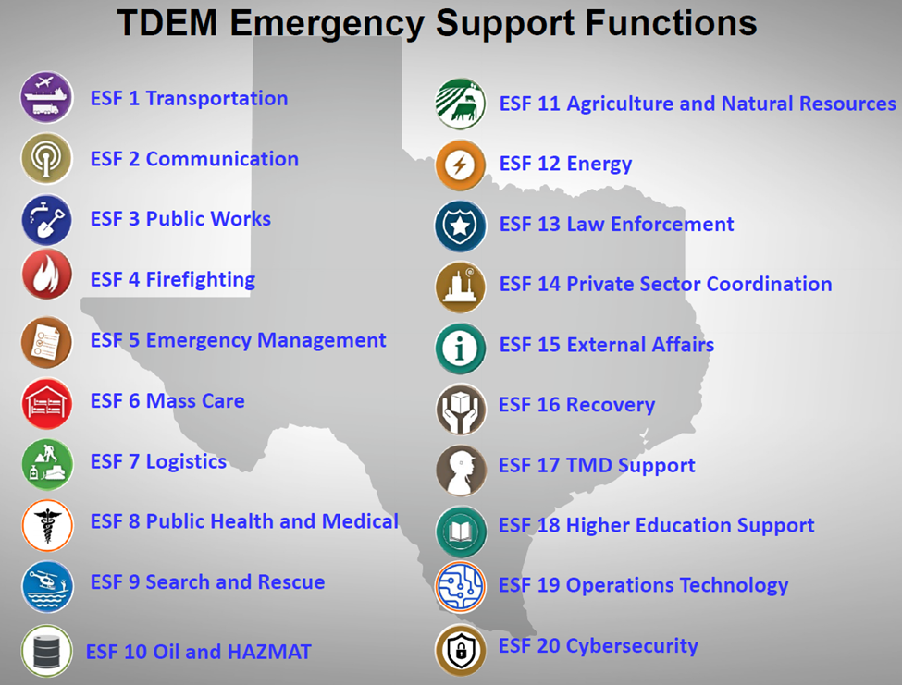

The following maps show the major highways that intersect with the path of totality. The yellow line represents the center of the path of totality:

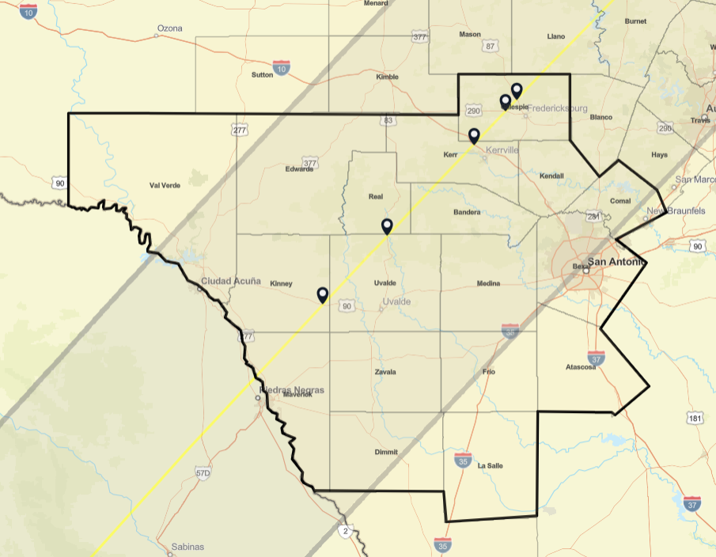
Region 6:

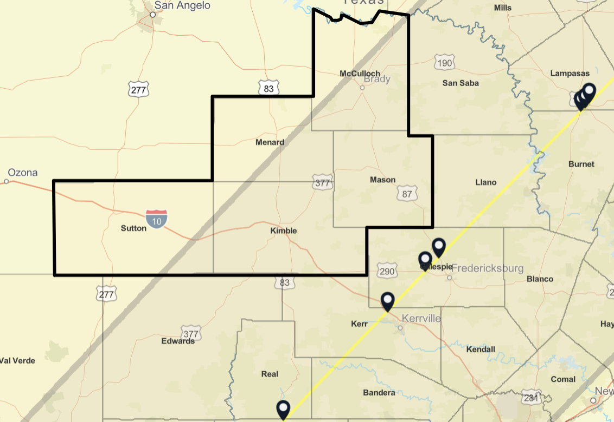
Region 7:

Region 8:
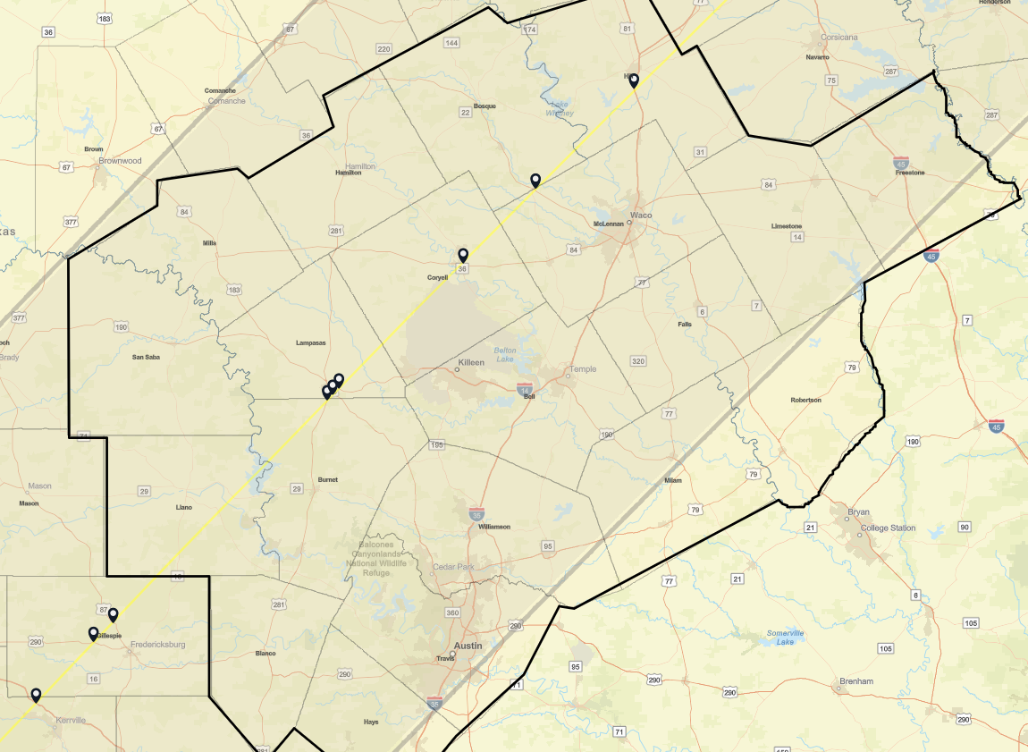

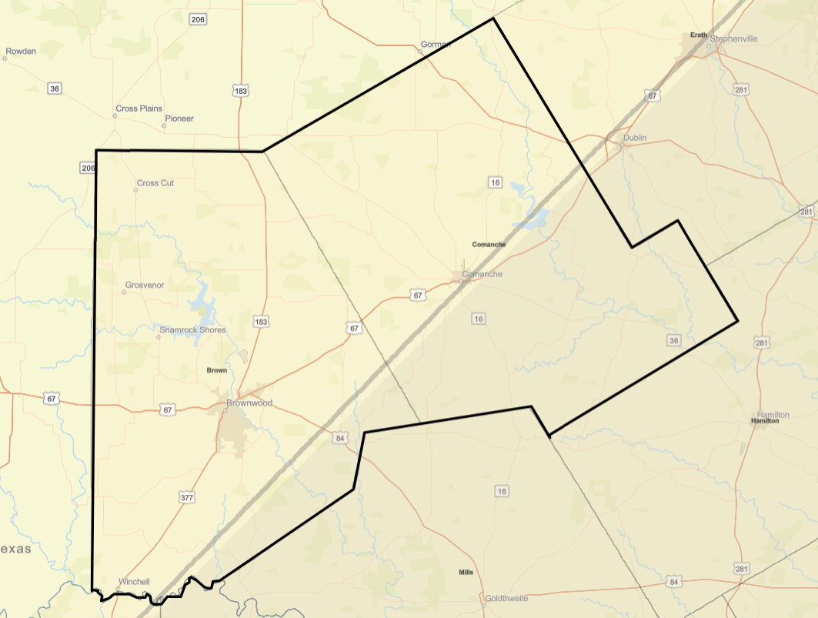
Region 1:

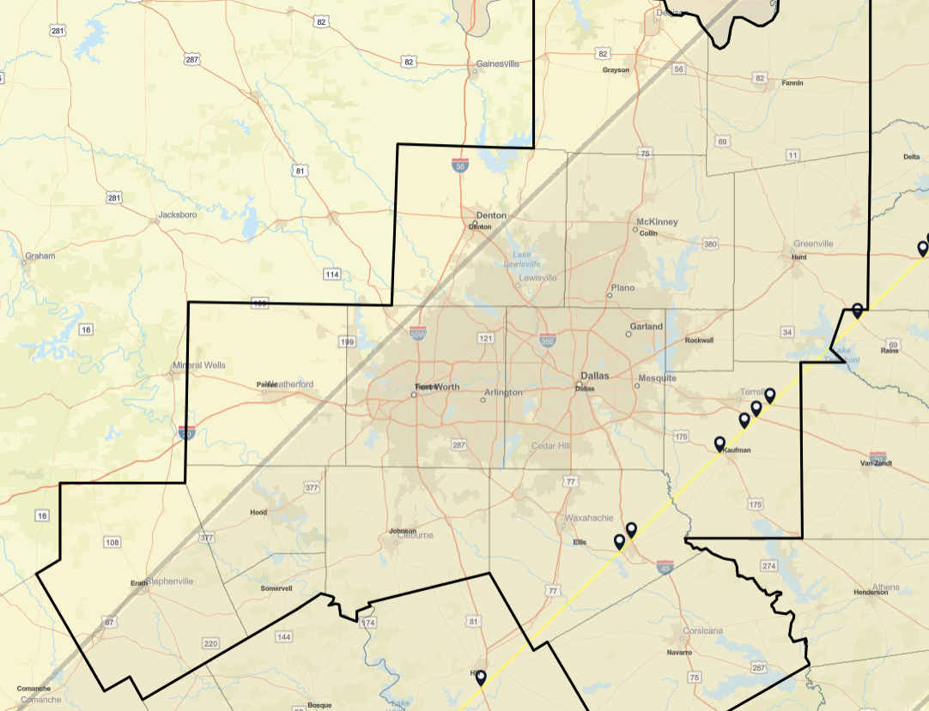
Region 2:

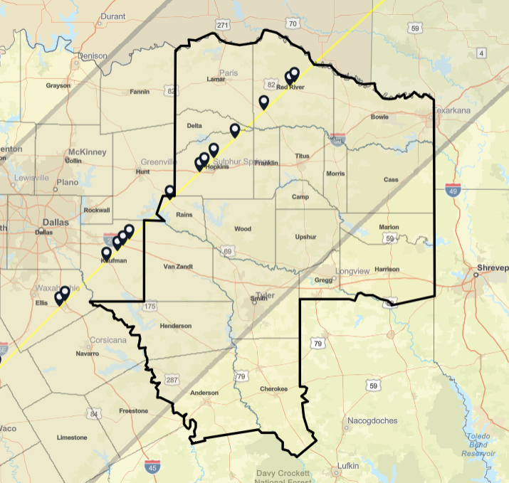
Region 3:

The table below shows the historic average weather for April 8th for the major cities near the path of totality:

City | Temperature | Precipitation
San Antonio | 79° | 4.60”
Austin | 73° | 5.5”
Waco | 73° | 5.5”
Dallas | 73° | 5.5”
Fort Worth | 73° | .07”
Plano | 73° | 5.5”
Average | 74° | 4.46”

The table below shows the estimated lodging capacity for the cities in the path of totality:

City | Hotel/Motel | Short-Term  Rentals | RV Parks | Estimated Total Capacity
Uvalde | 1,920 | 352 | 180 | 2,452
Kerrville | 720 | 304 | 540 | 1,564
Fredericksburg | 1,440 | 480 | 540 | 2,460
Copperas Cove | 1,200 | 192 | 180 | 1,572
Gatesville | 1,200 | 128 | 360 | 1,688
Sulphur Springs | 1,680 | 320 | 180 | 2,180
Total: |  |  |  | 11,916

The table below shows the estimated lodging capacity for the major cities near the path of totality:

Major City of Concerns | Hotel/Motel | Short-Term Rentals | RV Parks | Estimated Total Capacity
San Antonio | 140,000 | 8,000 | 1,260 | 149,260
Austin | 134,000 | 8,000 | 1,800 | 143,800
Waco | 47,060 | 3,572 | 1,260 | 51,892
Dallas | 160,000 | 8,000 | 1,620 | 169,620
Fort Worth | 135,000 | 8,000 | 2,520 | 145,520
Plano | 115,000 | 8,000 | 1,440 | 124,440
Total: |  |  |  | 784,532

The table below shows scheduled events in major cities near the path of totality:

City | Organizer | Dates | Estimated Attendance
San Antonio | Great Texas Airshow 2024 at Joint Base San Antonio | April 6-7 | 250,000-550,000
 |  | Total | 550,000

City | Organizer | Dates | Estimated Attendance
Austin | CMT Music Awards at Moody Center | April 7 | 15,000
 | Statesman CAP10K, Downtown Austin | April 7 | 15,200
 | Utopiafest Down in the Oaks | April 5-9 | 5,000
 | Katie Pruitt at the Parish | April 7 | 2,300
 | Total Eclipse Viewing Party | April 8 | 2,000
 | Total Eclipse of the Park | April 8 | 3,500
 | Eclipse & Sips Rooftop Viewing Party Hilton Austin | April 8 | 1,602
 |  | Total | 44,602

City | Organizer | Dates | Estimated Attendance
Waco | Waco Symphony Orchestra: Sci-Fi Spectacular: Sun, Moon & Superstars | April 5-7 | 2,200
 | Eclipse Over Texas McLane Stadium | April 8 | 45,150
 |  | Total | 47,350

City | Organizer | Dates | Estimated Attendance
Dallas | Houston Rockets at Dallas Mavericks American Airlines Center | April 7 | 21,146
 | Jonah Kagen House of Blues Dallas | April 7 | 2,500
 | Totality Dallas Samuell Farm | April 6-8 | 5,000
 |  | Total | 28,646

City | Organizer | Dates | Estimated Attendance
Fort Worth | Ultimate Bull Fighter at the Cowtown Coliseum | April 7 | 3,418
 | LA BOHÈME Fort Worth Opera | April 7 | 2,042
 | Total Solar Eclipse Fort Worth Museum | April 8 | 3,369
 |  | Total | 8,829

City | Organizer | Dates | Estimated Attendance
Plano | Total Eclipse Watch Party Plano Municipal Center | April 8 | 5,000
 | Total Solar Eclipse at the Haggard Library | April 8 | 1,500
 |  | Total | 6,500

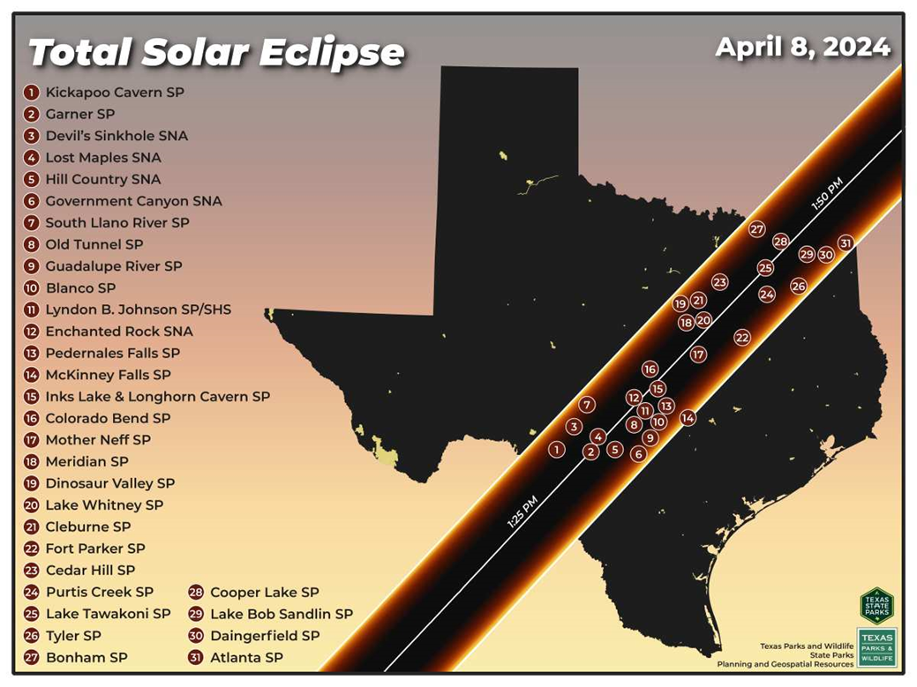
Below is an image showing the various state parks and state natural areas within the path of totality:

Planning Assumptions
For this plan’s development, certain planning assumptions have been made. They serve as the basis for decision-making and setting expectations. These assumptions are derived from analysis, data, expertise, and current trends. These assumptions are essential for creating realistic plans, as they provide the framework for understanding possible challenges. Planning assumptions relevant to this annex are listed below:
- Traffic impact throughout the affected areas will increase as the total eclipse approaches and passes.
- Traffic will be impacted after the total eclipse as visitors/spectators depart the area.
- Large viewing crowds and motorists pulling their vehicles over on major roadways will necessitate traffic controls and patrolling.
- State parks and state natural areas within the affected counties, and major highways that intersect with the path of totality, will be potential traffic choke points.
- Vehicle crashes, stalled vehicles, medical emergencies, and various other incidents that may occur on the road during traffic congestion may hinder emergency responders’ ability to respond to incidents in a timely manner.
- Many motorists will be unaware of the eclipse, and unprepared to view or travel during it.
- Highway construction zones, lane closures, and oversized/overweight vehicles may cause extra strain on the expected traffic congestion, and proper coordination should occur between the state and local jurisdictions before any temporary restrictions are planned during the solar eclipse event.
- Affected counties with lakes or other bodies of water may experience increased waterway traffic as people attempt to use boats or other watercraft to view the solar eclipse.
- A sharp increase in cell phone usage may overwhelm cellular networks, especially in rural or non-urban areas.
- Emergency call centers may experience a surge in 9-1-1 or non-emergency calls, including calls from uninformed citizens who were unaware of the solar eclipse event.
- The population surge may cause a strain on public drinking water and wastewater systems, creating a need for potable water distribution and portable toilets.
- An increase in debris along roadways and in state parks/natural areas may need to be managed during and after the solar eclipse event.
- With the camping grounds at state parks and state natural areas being at or near capacity, the potential for human-caused wildfires may be high.
- Motorists who toss cigarettes, or other flammable items from their vehicles, may cause a wildfire in grassy medians or wooded areas along the roadways.
- A sharp increase in population may overwhelm lodging facilities, especially in rural or non-urban areas.
- Medical emergencies may occur at different sites simultaneously, requiring outside medical transportation assets to be requested.

- Proper prevention and preparedness programs, such as public awareness of safe viewing methods, will prevent or reduce eclipse-related injuries.
- A surge in medical care may overwhelm hospitals and other medical facilities, especially in rural or non-urban areas.
- Local mutual aid within affected areas may be unavailable as resources are committed to simultaneously pre-planned local events.
- The event will take place at the peak of tornado season and during baseball season, which may impact the availability of resources.
- Resources may be prioritized for the jurisdictions in the path of totality.

Most Probable Event Scenario
It is estimated that nearly one million solar eclipse spectators could visit areas within the path of totality from Sunday, April 7 to Tuesday, April 9. For the 83 affected counties within the path, this could be an average of 12,048 potential spectators per county. There are 44 counties that will experience 100% totality, which could attract an average of 22,727 potential spectators per county for those 44 counties.
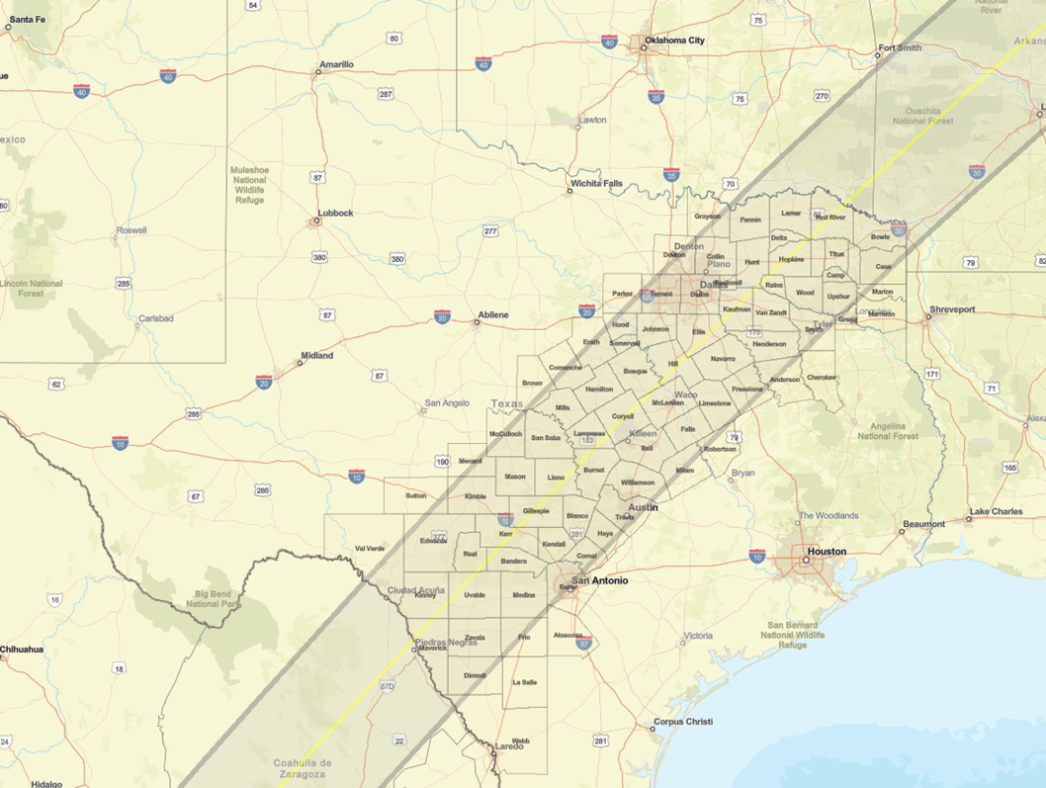
On the day before or during the early morning hours of the event, spectators who travel to and lodge in the major urban areas along the path may travel one or two hours from their lodging to find viewing sites. After the event, they may remain in the area until at least Tuesday morning. The movement patterns for this event are comparable to a professional or college football game scenario, potentially representing similar hazards affecting each jurisdiction along the path.

Rural jurisdictions within the path could see a potential 200 percent increase in population. This would strain the public safety and private sector resources in these areas. Urban jurisdictions within the path should be able to manage the spectators but may need additional assistance to ensure interstate and other major highways are not impeded.

Areas of Concern:

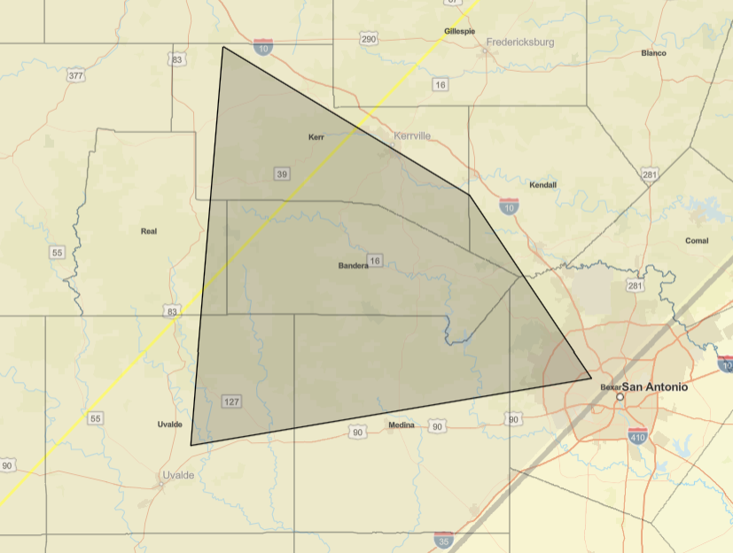
West of San Antonio in an area bordered by Interstate Highway 10, United States Highway 83, and United States Highway 90.

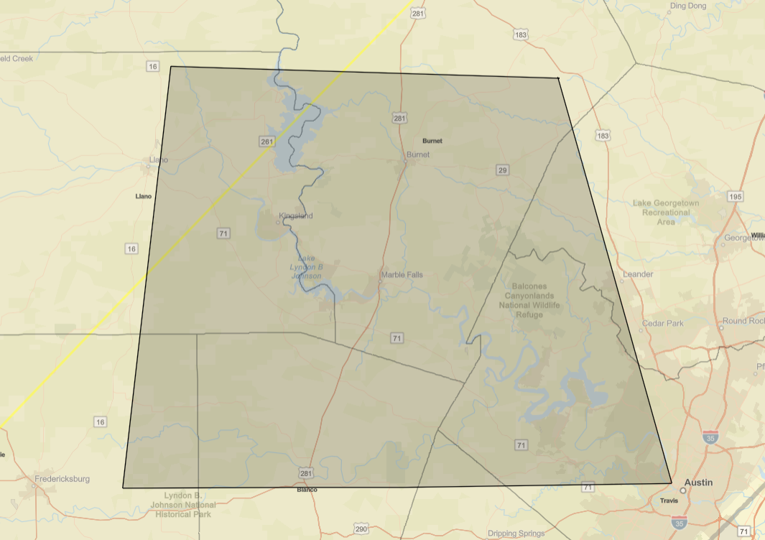
West of Austin in an area bordered by Interstate Highway 35, United States Highway 183, State Highway 16, and United States Highway 290.

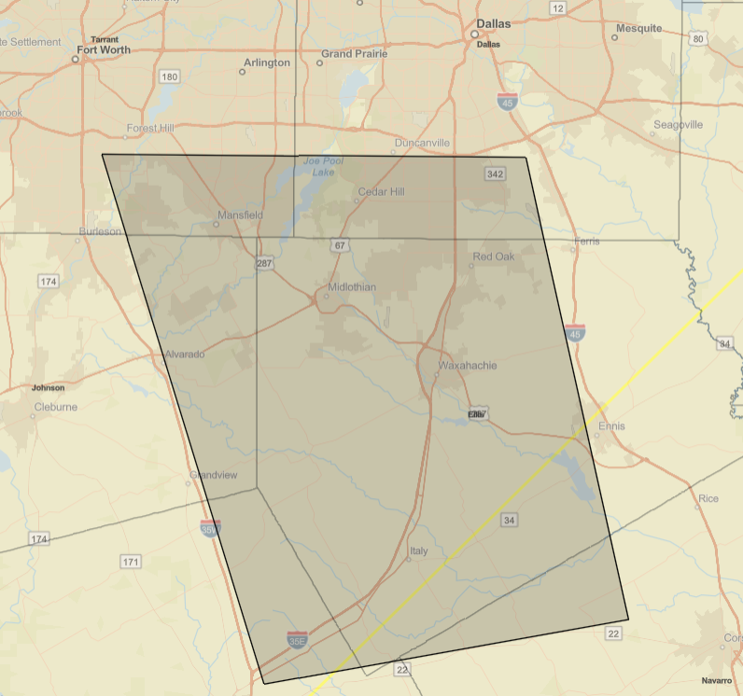
South of Dallas in an area bordered by Interstate Highway 45, Interstate Highway 20, Interstate Highway 35W, and State Highway 22.

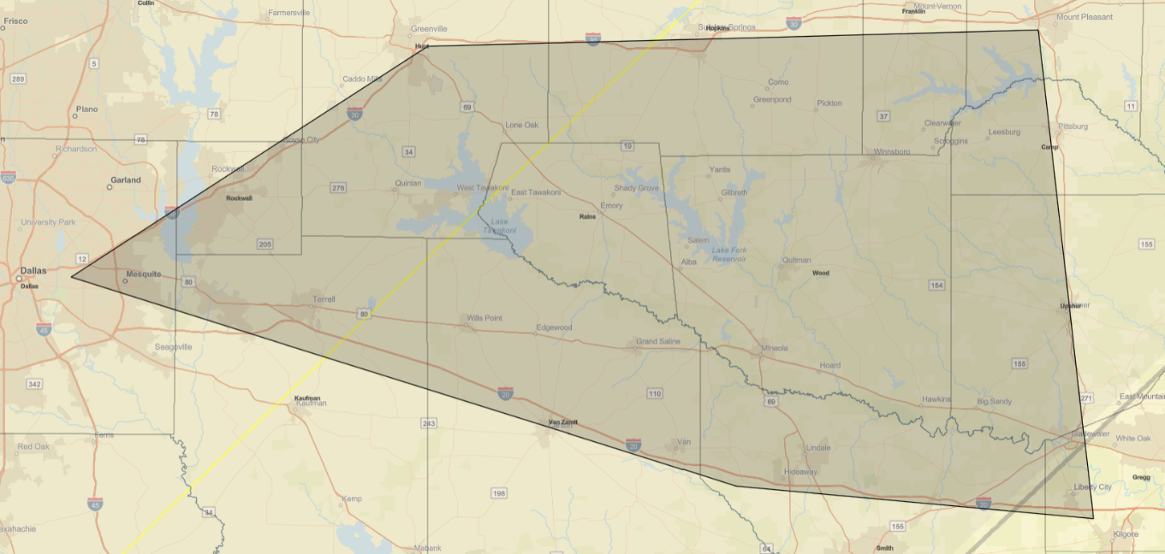
East of Dallas in an area bordered by Interstate Highway 30, Interstate Highway 20, and United States Highway 271.

Concept of Operations

The primary intent of this plan is for local jurisdictions that host or expect an influx of solar eclipse spectators to their jurisdictions to prepare in advance for potential emergency situations.

Due to a surge in spectators, estimated between 180,000 and 720,000, the Texas Division of Emergency Management sees the potential for emergency situations arising in transportation, communication, public safety, and other sectors. Local communities, especially rural communities, may need assistance managing the high number of visitors as the influx may overwhelm their resources and infrastructure.

Phases and Objectives
The following table lists the state-level phases and their objectives needed to support solar eclipse operations:

 | Preparedness Phase | Response Phase | Recovery Phase
Objective 1 | Ensure that local officials, private sector partners, and the public are aware of potential hazards, and that situational information is sent to the State Operations Center | Ensure that local officials, private sector partners, and the public are aware of active hazards, and that situational information is sent to the State Operations Center | Ensure that local officials, private sector partners, and the public are aware of remaining hazards, and that situational information is sent to the State Operations Center
Objective 2 | Confirm the extent of the event with local, private, state, and federal partners | Manage traffic in the affected area to ensure first responder access to incidents and unimpeded commercial traffic transit | Manage traffic in the affected area to ensure first responder access to incidents and unimpeded commercial traffic transit
Objective 3 | Determine if the event will require state resources | Position all state resources to support local response efforts as quickly as possible | Support local jurisdictions and affected state properties with debris management
Objective 4 | Consider potential resource needs and if prepositioning of resources is warranted | Coordinate communications resources in the affected area to mitigate disruptions to public safety or cellular communications | Confirm that all state resources are demobilized in a timely manner

The Texas Division of Emergency Management may assign resource requests as situations develop.

Organization and Assignment of Responsibilities
Based on the hazards and assumptions identified, each affected region within the path of totality may be assigned a branch composed of resources from the emergency support functions identified.

Staged resources would need to be identified. The number of resources for each branch will be determined as the situation develops. All branches would mutually support each other.

The following map shows an example of regional branch staging areas that align with the path of totality in San Antonio, Austin, Dallas, and Texarkana:

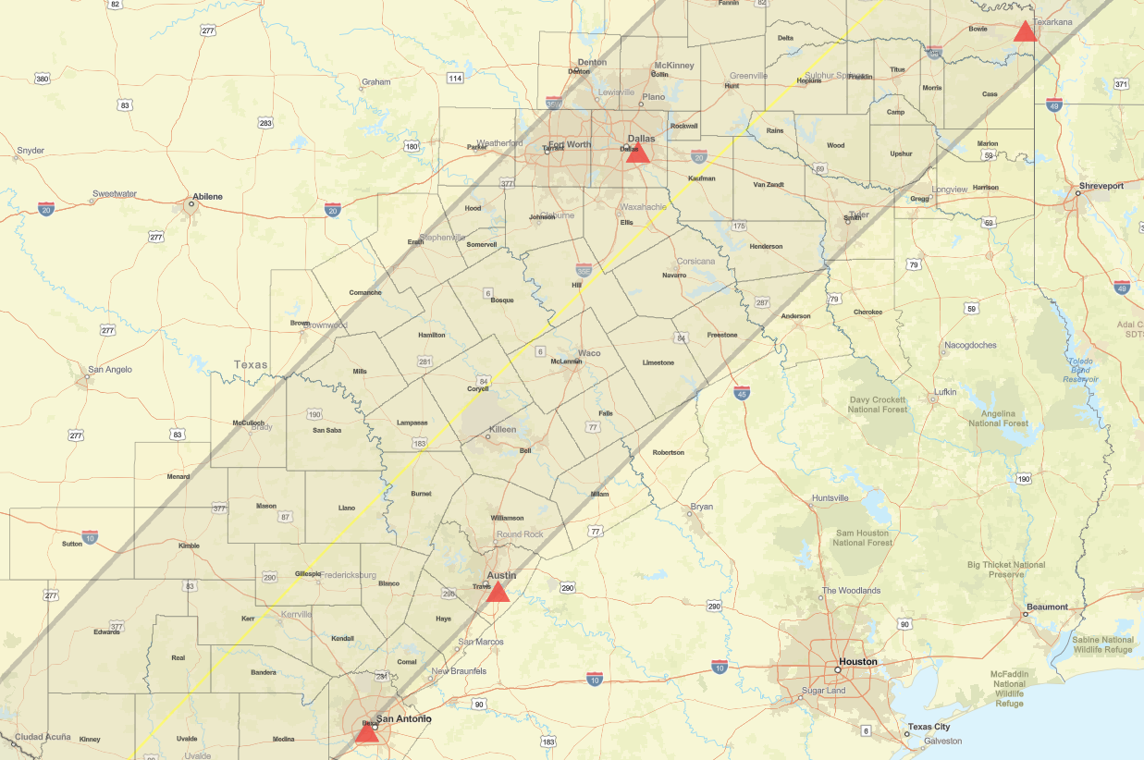

Direction, Control, and Coordination

Phase 1: Preparedness
March 1 – April 6, 2024
Phase 2: Response
April 6 – April 8, 2024
Phase 3: Recovery
April 10 – April 30, 2024

Information Collection, Analysis, and Dissemination
Information will be shared among regional staff and the Texas Emergency Management Council members via a solar eclipse working group established in Teams.

All other information collection, analysis, and dissemination will follow the Basic Plan and established emergency support function annexes.

Communications and Coordination
Emergency Support Function 2 – Communication coordinates communications interoperability with:
- Federal Emergency Management Agency, Region 6
- Department of Homeland Security, Cybersecurity and Infrastructure Security Agency
- State of Arkansas emergency communications partners
- State of Louisiana emergency communications partners
- State of Oklahoma emergency communications partners

For more information on Communications and Coordination, refer to Emergency Support Function 2 - Communication and Emergency Support Function 5 - Emergency Management.

Administration, Finance, and Logistics

Administration
The Texas Division of Emergency Management encourages stakeholders to become familiar with this document and provide feedback to improve the plan.

Documentation
All Texas Emergency Management Council agencies will provide after-action report comments to the exercise unit via tdem.exercises@tdem.texas.gov by April 30, 2024.

For other information on documentation, refer to the Basic Plan and Emergency Support Function 5 - Emergency Management.

Finance
For information on general finance-related issues, refer to Emergency Support Function 7 - Logistics.

Logistics
For information on general logistics-related issues, refer to Emergency Support Function 7 - Logistics.

Authorities and References
The laws, rules, and/or policies that provide general authority for the missions and activities described in the Solar Eclipse Event Plan can be found in the Basic Plan. Additional authorities specific to this event plan, if any, may be found in the other emergency support function annexes.

- AIRDNA. (2024, feb 5). Retrieved from https://www.airdna.co/
- Antonio, S. S. (2022). Great Texas Airshow at Joint Base San Antonio-Randolph a success. San Antoni: SBG .
- Antonio, S. S. (2022, april 24). Great Texas Airshow at Joint Base San Antonio-Randolph a success. Retrieved from https://news4sanantonio.com/news/local/great-texas-airshow-underway-at-joint-base-san-antonio-randolph-planes-thunderbirds-f35-air-force-usa-jets-usaf
- Carter, J. (2024, jan). Where will the most crowded places be for the total solar eclipse on April 8, 2024. Retrieved from Space.com: https://www.space.com/most-crowded-places-for-total-solar-eclipse-april-2024
- Parks, F. R. (2024). Find RV Parks. All Areas: Find RV PArks. Retrieved from https://news4sanantonio.com/news/local/great-texas-airshow-underway-at-joint-base-san-antonio-randolph-planes-thunderbirds-f35-air-force-usa-jets-usaf
- Parks, F. R. (2024, Feb 5). Find RV Parks. Retrieved from Find RV Parks: https://www.findrvparks.com/
- Weather Underground. (2023). Weather forecast. Affected Areas: Weather Underground.
- Timeanddate. (2024, Feb). Retrieved from timeanddate: https://www.timeanddate.com/eclipse/in/usa/houston

Prepared by the Texas Division of Emergency Management, Preparedness Division. For more information, visit the Texas Emergency Management website at https://tdem.texas.gov/preparedness/state-planning.

